**Startup Failure Post-Mortems 2018 Third Update (11/14/2018)**

### **Theranos**

Title: [Theranos is shutting down](https://www.nytimes.com/2018/09/05/health/theranos-shutting-down.html?login=smartlock&auth=login-smartlock)  
Title Link: <https://www.nytimes.com/2018/09/05/health/theranos-shutting-down.html?login=smartlock&auth=login-smartlock>

Product: [Theranos](https://www.cbinsights.com/company/theranos)  
Product Link: <https://www.cbinsights.com/company/theranos>

The New York Times wrote about the blood testing company and its plans to shutter operations:

‘We are now out of time,’ David Taylor, the company’s chief executive and general counsel, informed investors in an email first reported on Tuesday by The Wall Street Journal, whose in-depth investigation unraveled the company’s claims. Mr. Taylor declined to comment further, saying the letter spoke for itself.

# Theranos

HEALTHCARE | Medical Devices & Equipment / Patient Monitoring  
[theranos.com](https://theranos.com/)

## Founded Year

2004

## Stage

Dead | Dead

## Total Raised

$500M

## About Theranos

Theranos is a biomedical device company working on the field of Theranostics, the integration of technology with medical therapies to deliver the RIGHT drug, in the RIGHT dose, to the RIGHT patient at the RIGHT time. Theranos aims to provide clinical decision-support systems that enable pharmaceutical companies to develop safer, more efficacious drugs for individualized patient treatment.

## Theranos Headquarter Location

1701 Page Mill Road

Palo Alto, California, 94304,

United States

650-838-9292

# **Theranos Is Shutting Down**

Title Link: <https://www.nytimes.com/2018/09/05/health/theranos-shutting-down.html?login=smartlock&auth=login-smartlock>  
The Silicon Valley startup is expected to shutter its operations after it failed to deliver revolutionary lab-testing amid allegations of fraud.

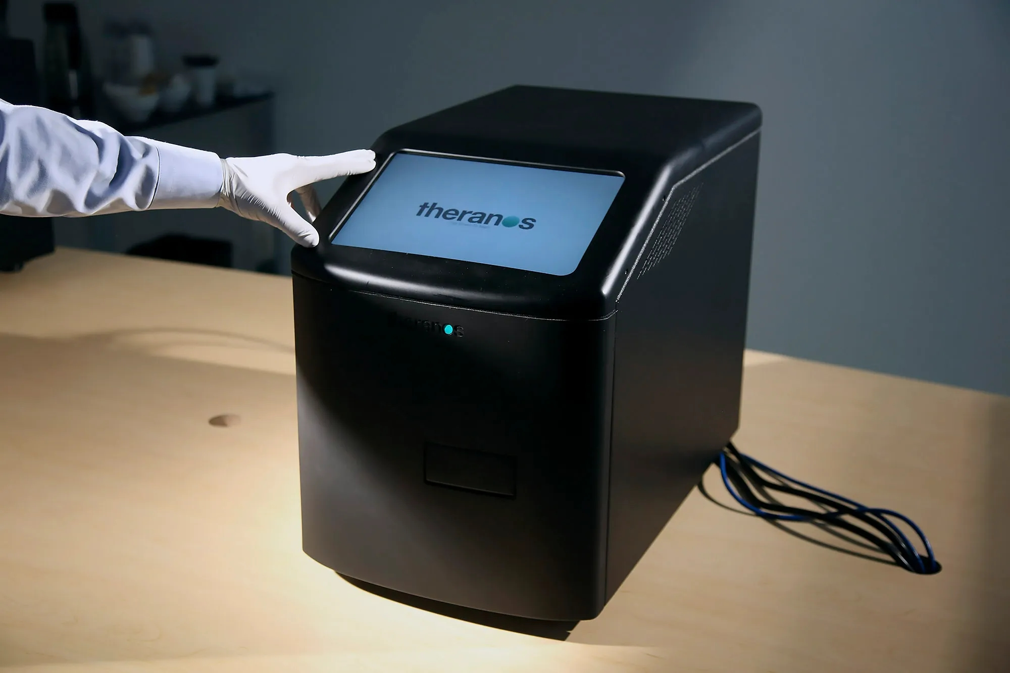Image: A blood-testing machine developed by Theranos in Palo Alto.JIM WILSON/THE NEW YORK TIMES/RE, source link: <https://www.wired.com/2016/10/theranos-blew-didnt-ruin-biotech-startups-everyone/>